Food Web Assignment
Name: __________________________________ Due Date: ___________________ Mark ____ /21
Dr Ketut Ildlife and Dr Imogen Ovecology are two biologists who observed the feeding habits of animals and plants around a small freshwater creek and pond over four months. Below is an extract from a journal report of their recent observations.
“We found a number of types of water plants growing in the pond and the creek that flowed into it. Many animals such as turtles and water hens ate these plants. There were also water lillies growing in the pond. Underneath the water lilly leaves, many small animals such as snails, water insects and eggs were found. We did not see any animals eat the water lillies leaves.
The water contained green algae, which was eaten by the tiny water fleas and mosquito larvae. The water fleas were almost microscopic and they were eaten by small fish, water beetles and shrimp.
Snails moved slowly over the rocks in the creek and ate the green algae on the rocks. Turtles also ate the algae. Water beetles ate mosquito larvae and small fish, as well as shrimp if they could catch them.
At night we observed frogs eating water beetles and mosquito larvae. Green snakes ate small fish, frogs and water beetles.

During the day, herons would fly into the pond to feed on the water beetles, snails and fish.”

Dr K.W.Ildlife & Dr I.L.Ovecology p45. Biology Today, Vol 9, 2013
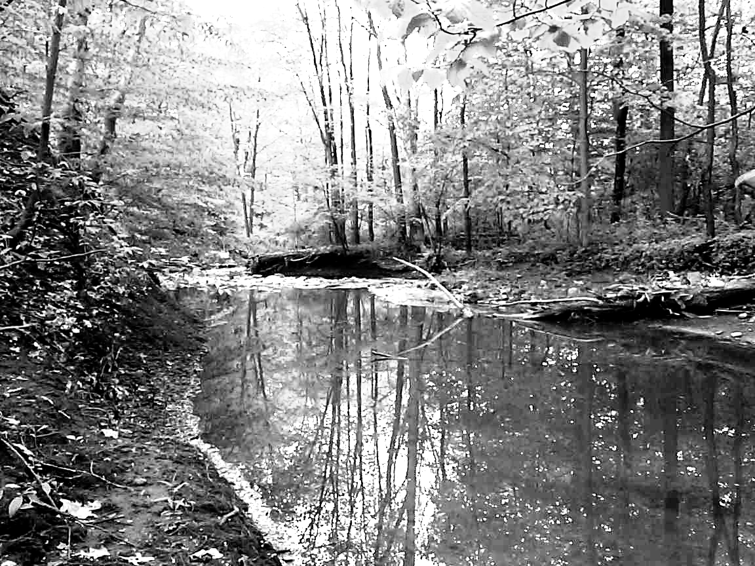
Biologist Dr I.L.Ovecology ---- Qualitative Data Collected 21 Feb. – 26 June 2013

Some of the organisms seen during the survey

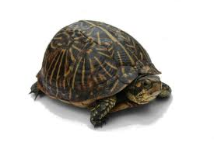
Turtles

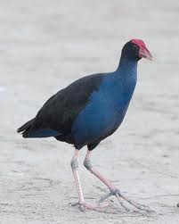
Water hens

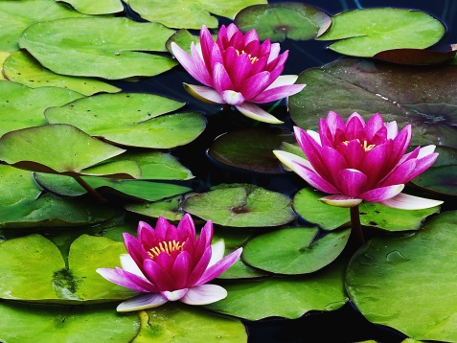
Water lillies

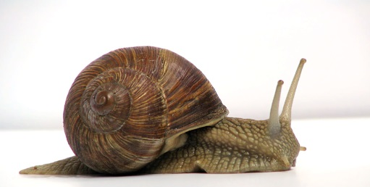
Snails

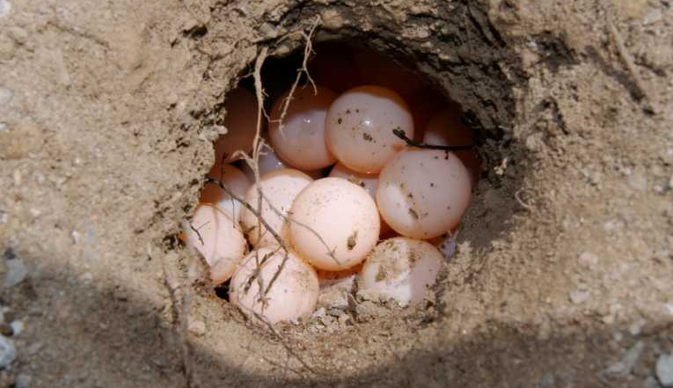
Eggs

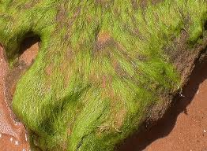
Green algae

Water fleas

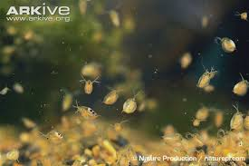

Mosquito larvae
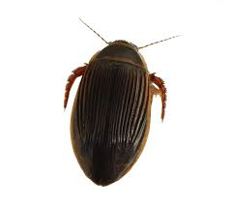
Water beetles

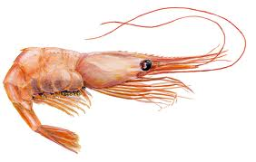
Shrimp

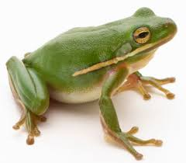
Frogs

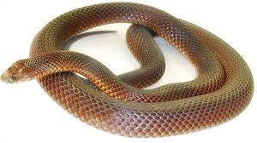
Snakes

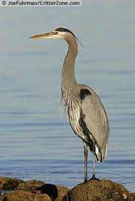
Herons

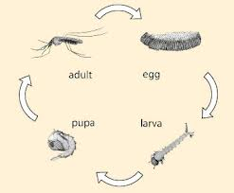
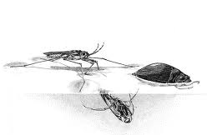

Water Insects

Please complete the following questions.
- Draw a food web from the biologists’ observations. (4 marks)

- Which organisms are:
  - Producers in the food web?_____________________________________________________
_______________________________________________________________________(1 mark)
  - Which are herbivores? _________________________________________________________
______________________________________________________________________________________________________________________________________________________(1 mark)
  - Which are second order consumers?______________________________________________
______________________________________________________________________________________________________________________________________________(1 mark)

- Are there any organisms in the creek and pond that were not eaten by other organisms? (1 mark)
________________________________________________________________________________
________________________________________________________________________________
- From the food web, draw a food chain that included algae, snakes and water beetles. (2 marks)

- Herons can be in a food chain that included water beetles and shrimp.
Draw the food chain. (2 marks)

- What would happen to the numbers of other organisms in the creek and pond if the number of fish suddenly increased? Explain. (3 marks)
________________________________________________________________________________________________________________________________________________________________________________________________________________________________________________________________________________________________________________________________________________________

- Why are water lilies important to some of the animals in the creek and pond? (1 mark)
________________________________________________________________________________________________________________________________________________________________________________________________________________________________________________________________________________________________________________________________________________________

- Do you think that this food web would be the same through the whole year, through the seasons?
___________________________________________________________ (1 mark)
Give reasons for your predictions. (1 mark)
________________________________________________________________________________
______________________________________________________________________________________

- What other factors may influence the life in the creek and pond (ones not included above)? (3 marks)
____________________________________________________________________________________________________________________________________________________________________________
Choose one of the factors you mentioned and give a possible major effect ______________________________________________________________________________________
____________________________________________________________________________________________________________________________________________________________________________
Explain why you think it would have this effect. _____________________________________________________________________________________
___________________________________________________________________________________________________________________________________________________________________________

